**ASSIGNMENT-3**

*Sugandhi Arora*

*B-12, 2017074*

**USE CASE**

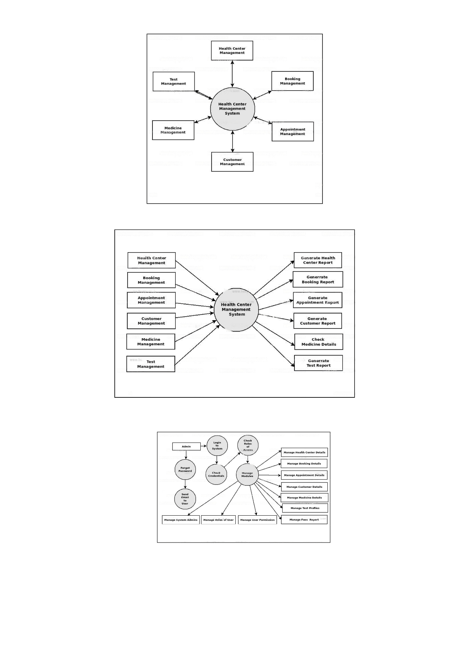**DATA FLOW DIAGRAM**

**FUNCTIONAL REQUIREMENTS:**

1. Real-time monitoring of vital signs: The system should be able to collect and analyse data from sensors and medical devices to monitor a patient's vital signs, including blood pressure, heart rate, and oxygen saturation.
2. Diagnosis and treatment recommendations: Based on the patient's medical data, the system should be able to provide a diagnosis and recommend appropriate treatment options to healthcare providers.
3. Alert system: The system should be able to send alerts to healthcare providers if there is a potential health risk or if the patient's condition worsens.
4. Electronic health record integration: The system should be able to integrate with electronic health records to provide a comprehensive view of the patient's medical history.

**NON-FUNCTIONAL REQUIREMENTS:**

1. Security: The system should have robust security measures in place to protect patient data from unauthorized access or cyber threats.
2. Scalability: The system should be able to handle a large volume of data and users as it grows.
3. Reliability: The system should be able to function reliably and consistently without downtime or errors.
4. Usability: The system should be easy to use for healthcare providers and patients, with a user-friendly interface and intuitive navigation.
5. Performance: The system should be able to perform quickly and efficiently, with fast response times and minimal delays.